L5. Self Awareness: Observing and recognizing one's own feelings.
Types of self-awareness

Understanding self-awareness. Self-awareness is the first step towards EI. Self-awareness involves having a deep understanding of one’s emotions, thoughts, behaviour, strengths, weaknesses, needs and drives. It’s about being aware of our psychological state of mind at any given point of time. Self-awareness should not be grossly unrealistic nor hopelessly pessimistic. We need to strike a golden mean by being honest and realistic with the help of accurate self-assessment.

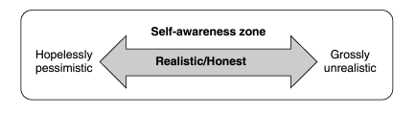

People with a high level of self-awareness recognize not only their own feelings but also that of people around them. They are more equipped to face demanding situations, as they would be able to consciously choose the right responses. Understanding of one’s values plays a major role here. People with self-awareness are more likely to make choices driven by their values and goals, rather than by circumstances and environmental triggers.
A high level of self-awareness leads to more accurate self-assessment. It makes us capable of demonstrating a self-deprecating sense of humour and to be more comfortable discussing our own limitations. It enables us to be open to constructive feedback. On the contrary, those with low self-awareness would view such feedback as a threat or as a sign of failure. People with a high level of self-awareness can be well recognized by their self-confidence. They are unlikely to give up when faced with challenging situations. They do not hesitate reaching out for help from others to get things done. With a high level of self-awareness, we will naturally give credit to where it belongs and acknowledge those who contribute. We would also have the capacity to self-assess in a realistic manner, leading to development. Our lives would be in turmoil if we fail to understand our own emotions and feelings. Self-awareness can be developed by being open to receiving feedback. All other components of EI germinate from self-awareness and its absence would insulate us from further developing our EI. In a study conducted by Lewis and Brooks-Gunn on self-awareness, they placed a red dot on the nose of infants and held them in front of a mirror. They arrived at the following conclusions. Around 25 per cent of the infants aged between 15 and 18 months reached for their own noses. About 70 per cent of those aged between 21 and 24 months also did the same. This shows that children develop some kind of self-awareness after the age of 15 to 18 months. Infants of age less than 12 months are unlikely to be self-aware. This experiment pertains to visual self-awareness. There are many other dimensions of self-awareness. Being self-aware is unique to human beings. Animals are devoid of this intelligence. There are traces of self-awareness evident in chimpanzees. It is suggested by researchers that the anterior cingulate cortex, located in the frontal lobe of the human brain, plays an important role in self-awareness. Humans have the unique capability of getting out of their bodies and visualizing themselves. This ability is important for the development of our EI. With the help of self-awareness, we become aware of our strengths, weaknesses and limitations. The most significant part of this capability is the ability to remain aware of the emotions that we experience and identify the causes for the same. Self-awareness is a strong predictor of our effectiveness in life. We can identify opportunities, threats and other related signals in a more effective manner and choose what is appropriate for us. We are often caught in the rigmarole of our daily lives and tend to avoid self-reflection until we are faced with severe challenges and failures.

Emotions and Feelings
Emotions are instinctive responses coming out of the amygdala, the limbic system of the brain. These responses generate biochemical and electrical reactions, basically neurological reactions to a stimulus. Imagine a mother waiting for her child to come back from school and is worried about the unusual delay. The moment she sees the child, the feelings experienced by her will help us to understand instinctive emotions. Emotions can be conscious or unconscious. We could lead our entire lives without understanding some of the emotions experienced by us. The mother might just run to hug the child in relief, without being conscious of her surroundings. Feelings are bodily reactions that are triggered by the activities of neurotransmitters and hormones. These are released into the brain, lending a conscious experience. In other words, emotions activate feelings that can then be experienced by us.
Feelings are influenced by beliefs, memories, thoughts and past experiences. Feelings include physical sensations of touch, hunger, pain, etc. When the mother sees the child safely back from school after the delay, she experiences joy while hugging the child and finds comfort in the bodily touch.
There are three dimensions of self-awareness that can be summarized into four questions:
1. What’s happening to me? The ability to understand what’s happening in our day-to-day lives. Where am I heading towards in terms of emotions? It also involves taking account of incidents happening around us, impacting our emotions.
2. What are my feelings? Emotions being experienced by us on a regular basis and the feelings that are generated. It helps us to understand the link between emotions and feelings.
3. Why am I experiencing these emotions? Introspecting who or what is the trigger or the root cause for the emotions that are being experienced.
4. What are the blind spots? The ability to reflect on our blind spots, which are aspects of us that we are unaware of. It is minimizing ignorance about ourselves and knowing about the unknown self.
Being unaware of our own feelings and emotions is the highest form of emotional illiteracy. Many significant challenges are faced in the absence of self-awareness. Learning how to remain self-aware is the first significant step towards developing EI.

Types of self-awareness
Extensive research on self-awareness has led to the identification of two distinct types. The initial school of thought termed it as selfconsciousness . Subsequently, two different aspects were identified: internal self-awareness and external self-awareness, according to Dr Tasha Eurich.
Internal Self-awareness
This refers to how distinctly one's own thoughts, feelings, behaviour, strengths and weaknesses can be observed. It further extends to our ability to observe our own values, aspirations, passion, compatibility towards the environment and the impact on others. Higher internal self-awareness is more likely to result in better El. Lack of it can lead to stress, lack of self-esteem and, in extreme cases, foolhardy actions.
External Self-awareness
The second dimension of self-awareness is the ability to see how others view us in the context of the same aspects mentioned earlier.
It indicates that those with higher external self-awareness are more likely to display empathy towards others. They can see how other people perceive them and hence are more likely to modify their behaviour, This enhances their chances of building better relationships. They are also perceived to be effective by other people.
It is easy to assume that if we have one type of self-awareness, we are likely to be high in the other. This is not true, as they are distinctly different. One can be highly internally self-aware, but lack external self-awareness and vice versa. On the basis of the levels of these two types of self-awareness, we can further understand the types of possible behaviours.
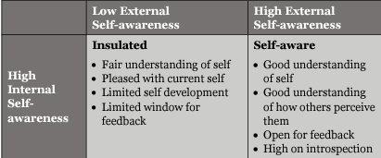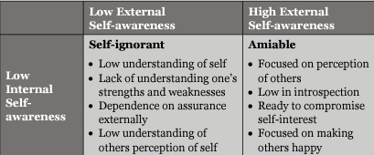

Insulated
They are pretty clear on who they are in their own eyes. They however do not challenge their views or search for blind spots by taking feedback from others. This can harm their relationships and limit their success.
Self-aware
They know who they are, what they want to accomplish, seek out and value others' opinions. These are the leaders who fully realize the true benefits of self-awareness.
Self-ignorant
They don't yet know who they are, what they stand for or how their teams perceive them. As a result, they might feel stuck or frustrated with their performance and relationships.
Amiable
They can be so focused on appearing a certain way in the eyes of others that they could be overlooking what really matters to themselves. Over a period of time, they tend to make choices that are detrimental to their own comfort and fulfilment.

ELEMENTS OF SELF-AWARENESS
There are three elements of self-awareness, namely emotional awareness, accurate self-assessment and self-confidence.
Emotional Awareness
It is about recognizing one's emotions and their effect on us. Humans are a bundle of emotions, and we experience a diverse set of emotions in our day-to-day lives. The ability to be aware of the emotions being experienced at all times is emotional awareness. Once this awareness is gained, we could make effective choices.
Accurate Self-assessment
Self-assessment is understanding one's strengths, weaknesses and limitations, leading to self-confidence. Higher the self-assessment, better would be our ability to take decisions on the basis of the choices offered.
Self-confidence
Self-confidence is having a sense of self-worth and thereby not being threatened by people and situations around them. High self-confidence increases our trust in people and enhances our ability to receive criticism and feedback gracefully.
Self-awareness cannot be developed only through experiences gained in life. At times, we remain blind to some of our habitual behavioural patterns and fail to question them. In a research conducted among managers, it was learnt that more the experience, less the ability to self-assess their leadership effectiveness.
According to Dr Tasha Eurich, when 3,600 leaders across various roles and industries were studied, it was conclusive that the more power they held, the more their tendency was to overestimate their stalls and abilities in comparison with the perception of others.
This pattern was reflected on 19 out of 20 competencies researched, including emotional self-awareness, accurate self-assessment, empathy, trustworthiness and leadership performance. This could most likely be due to the fact that the more senior a leader, the lesser the number of people to provide them with feedback.
More power leaders wield in organizations, lesser would be the comfort in others around them to provide them feedback. Professor James O'Toole adds that when one's power grows, one's willingness to listen shrinks, either because they think they know more than the team members or because seeking feedback comes at a cost.
This can be changed for the better. The research further indicated that most successful leaders change this tendency by seeking frequent feedback from bosses, peers and subordinates. This helps them to be internally and externally self-aware. They seek critical feedback from their superiors and subordinates, particularly from the people they trust, which helps them develop their external self-awareness in particular.
GAINING SELF-AWARENESS
THROUGH FEEDBACK
Feedback is one of the most effective ways to develop self-awareness.
In an organization context, "360-degree feedback' is a very effective mechanism. Feedback can be a challenging process, as it might shake our self-perception and established thoughts about ourselves.
We need a lot of courage to be open to feedback.
It is also equally important to choose the right people to seek feedback from. Those who are biased and have a hidden agenda would not be able to provide as with candid and honest feedback.
They would tend to either sugar-coat or deliberately drive their own agenda.

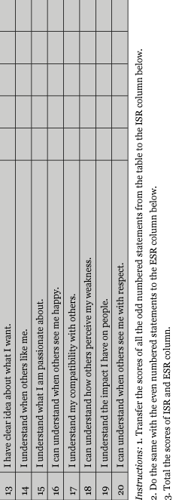
It's important to remember that we are getting into a vulnerable zone while seeking feedback. One of the effective ways to commence receiving feedback is to seek it from people we trust.

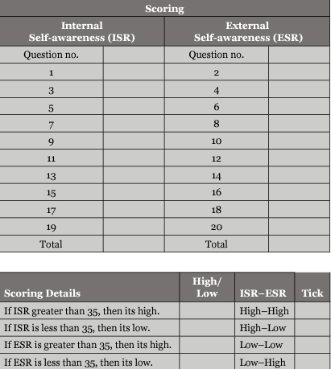

INTROSPECTION
'The other mechanism to develop self-awareness is introspection.
It is the process of self-reflection that leads to understanding the way we think, speak and behave. This needs investment of time in a quiet environment with no distractions. True introspection needs courage, as it might be uncomfortable to revisit some of our emotions and behaviours.
We may tend to avoid stepping into the zone of introspection with honesty. Many may deliberately seek distractions in order to avoid revisiting their unpleasant emotions and behaviours. The human mind is capable, if given the opportunity, of being self-aware with the help of introspection. Unless a conscious effort is initiated through reflection, self-awareness is unlikely to develop.
Introspection Based on 'Why' and 'What'
There is another challenge that we need to overcome in developing self-awareness through the process of introspection. Surprisingly, this provides a comparatively lesser benefit. Research indicates that those who depend only on introspection for examining their own feelings and behaviour were less self-aware. The problem is not with introspection but rather with the method
The challenge arises when we seek answering the question 'why during the introspection process. "Why is not an effective self-awareness development question. For the question, why did I lose my temper with a particular team member', we might not have the answer due to our subconscious thoughts, feelings and motives.
We, therefore, become incapable of eliminating those biases while answering the question "Why'
We are inherently programmed to think and act in a particular fashion. Hence, the introspection process has a challenge. Let's take an example: "Why did I lose my temper on John?* The mental response is I gave John adequate warnings and had no choice but to lose my temper." We are enveloped by the defence of justification.
A more effective form of introspection is what rather than why.
Questioning what triggered the particular behaviour or action* would provide a much better understanding, leading to higher self-awareness.
In a study conducted by psychologists Dr J. Gregory Hixon and Dr William Swann, undergraduates were provided with negative feedback on their sociability, likability and how interesting they are as a person. Some set of students were asked to introspect on Why such a feedback was received by them?' The other set of students were asked to introspect on What could be the possible reasons for such a feedback?
The conclusion of the study was that the students who introspected on the basis of the paradigm of why were engaged in justifying and defending themselves. The other group was comparatively more focused on what were the reasons for the feedback'. Hence, they were more open to learning from the feedback.
Let's take Sandeep's example.
Sandeep heads the business development department in a technology company. His department had missed achieving revenue targets for two consecutive quarters. When he analysed on why' he missed achieving the targets, multiple thoughts were likely to have crossed his mind. He would have attributed the failure to a lack of support from his technical team, lack of skill set in his team and a poor communication strategy.
When he switched over to the question what are the possible reasons, the following thoughts were likely to have crossed his mind- lesser interaction with the technical team, inadequate training for his team on selling skills and his lack of involvement in designing the communication strategy. "What' generated solution-oriented and more constructive thoughts in his mind. Hence, 'what was a more effective way to introspect as compared to why'.

